Self Pay
Policies
Clients with NO Insurance Coverage using Self Pay must sign our Self Pay Agreement LINK: https://intakeq.com/new/ZADe77
Clients WITH Insurance Coverage who are electing to use Self Pay must sign our Opt Out of Insurance & Self Pay Agreement LINK:
https://intakeq.com/new/HVFEDi

Scheduling/Billing
Use the Self Pay Primary “Billing” Codes. The full rate will automatically populate. Do NOT change the rate.
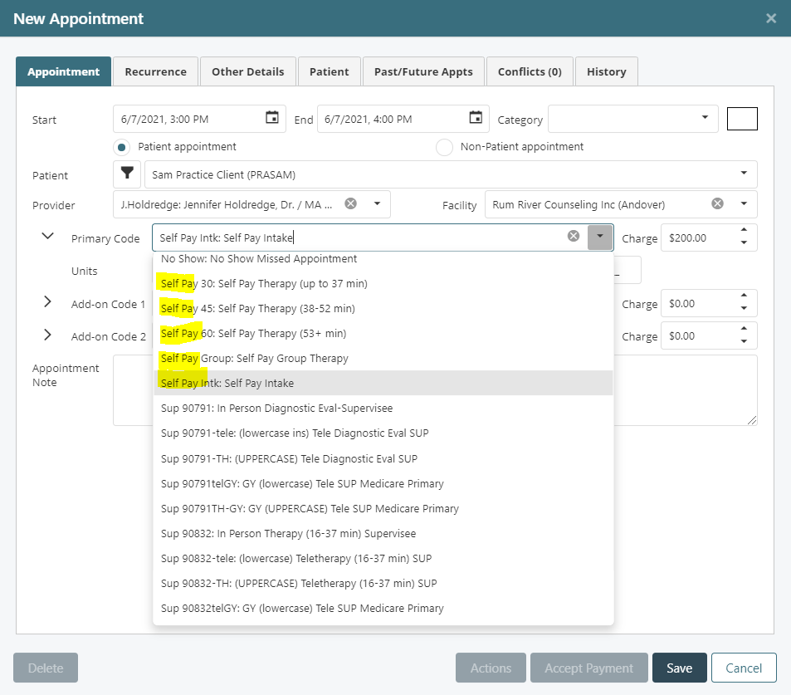

Use Accept Payment when running the Credit Card. The full rate will populate again. The amount that the patient is paying for the visit is entered in the Total Payment box. ONLY if this amount is less than our full rate, then you check the Write-off remainder as courtesy discount box.
